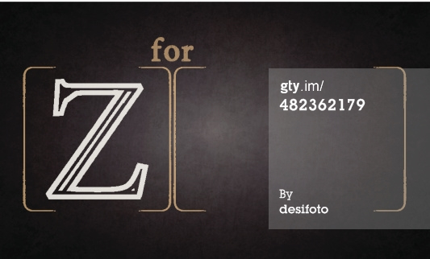Trip to Delhi

Snehan Gorain

BTT101

Mr Buffone

21/01/2015

**Z E D E D U C A T I O N**

|  |  |  |  |
| --- | --- | --- | --- |
|  | **Details** | | |
| **Air Travel**   1. Airline Name Flight # (to destination) Flight # (from destination) 2. Departure date 3. Home Arrival date 4. Website (URL) 5. Date you found info 6. Price (1 ticket) | Jet Airways  9W229  9W230  June 23 2015  June 28 2015  <https://secure.jetairways.com/Jetobe/OnlineBooking.aspx>  January 15 2015  $5557.00 | | |
| **Accommodation**   1. Hotel Name 2. Max # of persons per room 3. Website(URL) 4. Date 5. Price per room before taxes | Taj Mahal Hotel  2 people per room  http://www.tajhotels.com/luxury/city-hotels/the-taj-mahal-hotel-new-delhi/accommodations/luxury-suites.html  January 15 2015  ₹29,700.00 ($577.86) | | |
| **Attractions**   1. Attraction Name 2. Brief Description of Attraction 3. Price per person 4. Website(URL) 5. Date | Lal Qila (Red Fort)  The Lal Qila was built as the palace fort of  Shahjahanabad (Old Delhi) in 1638. It was designed to keep out invaders.  ₹250  <http://www.delhitourism.gov.in/delhitourism/tourist_place/red_fort.jsp>    25 June | Jama Masjid  Jama Masjid is the largest mosque in India, and the 8th largest in the world. It was built by emperor Shah Jahan in 1644 and can hold 25,000 people.  Free  <http://www.delhitourism.gov.in/delhitourism/tourist_place/jama_masjid.jsp>  26 June | Maqbarah-E-Humayun  Built in 1565 A.D by Humayun’s wife HajiBegum. It contains gardens and several graces of the Mughal rulers of Hindustan (India)  $250  <http://www.delhitourism.gov.in/delhitourism/tourist_place/humayun_tomb.jsp>  27 June |
| **Travel Requirements**   1. Passport? 2. Immunizations? 3. Restrictions? | A passport valid for at least 180 days and with at least two blank pages is required as well as a visa. Canadians must be in possession of a visa to visit India. You must obtain a visa prior to arrival or you will be refused entry into the country.  Holders of tourist visas can only stay in India for up to 180 consecutive days, even when the validity of the visa exceeds 180 days.  No Immunizations are required for travelers from Canada. | | |
| **Currency Conversion**   1. Name of currency 2. Rate of exchange for $1 CDN | Indian Rupee (₹)  INR 50.944 | | |

|  |  |  |  |  |
| --- | --- | --- | --- | --- |
| **Trip to Dehli** | |  |  |  |
| *# of business representatives travelling* | | |  | 8 |
| *Length of Trip (# of days required for hotel stay)* | | | | 4 |
| *# of persons per room* | |  |  | 2 |
| *# of rooms required per day* | | |  | 4 |
|  |  |  |  |  |
| *Cost per room per day for hotel* | | |  | 577.86 |
|  |  |  |  |  |
|  |  |  |  |  |
| **Individual (per person) Pricing** | | |  | **Cost (CAD)** |
| Cost for airfare | |  |  | $5,557.00 |
|  |  |  |  |  |
| **Attractions** |  |  |  |  |
|  |  |  |  |  |
| *Maqbarah-E-Humayun* | |  |  | 4.90734925 |
| *Jama Masjid* | |  |  | 0 |
| *Lal Qila* |  |  |  | 4.90734925 |
|  |  |  |  |  |
| *Total cost of Attraction per person* | | |  | 9.81469849 |
|  |  |  |  |  |
| **Group Pricing** | |  |  | **Cost (CAD)** |
|  |  |  |  |  |
| Cost for all airfare | |  |  | $44,456.00 |
|  |  |  |  |  |
| Cost for all rooms for hotel | | |  | 9245.76 |
|  |  |  |  |  |
| Total cost for attractions for all | | |  | 78.5175879 |
|  |  |  |  |  |
| Subtotal of all costs | |  |  | $53,780.28 |
| HST 13% |  |  |  | 6991.43609 |
|  |  |  |  |  |
| Grand total |  |  |  | $61,179.27 |
|  |  |  |  |  |
|  |  |  |  |  |
|  |  |  |  |  |
|  |  |  |  |  |
|  |  |  |  |  |
|  |  |  |  |  |
|  |  |  |  |  |
|  |  |  |  |  |
| **Currency conversion** | |  |  |  |
|  |  |  |  |  |
| **Indian Rupee** | |  |  |  |
|  |  |  |  | **Foreign** |
| **Canadian Dollars** | |  |  | **Currency Rate** |
| $ |  |  | 1 | 50.944 |
|  |  |  |  | **Total Amount** |
|  |  |  |  | **of Foreign** |
|  |  |  |  | **Currency** |
| $ |  |  | 250 | 12, 738.28 |

|  |  |  |  |  |
| --- | --- | --- | --- | --- |
| **Trip to Dehli** |  |  |  |  |
| *# of business representatives travelling* | | | | 8 |
| *Length of Trip (# of days required for hotel stay)* | | | | 4 |
| *# of persons per room* |  |  |  | 2 |
| *# of rooms required per day* | |  |  | 4 |
|  |  |  |  |  |
| *Cost per room per day for hotel* | | |  | 577.86 |
|  |  |  |  |  |
|  |  |  |  |  |
| **Individual (per person) Pricing** | | | | **Cost (CAD)** |
| Cost for airfare |  |  |  | 5557 |
|  |  |  |  |  |
| **Attractions** |  |  |  |  |
|  |  |  |  |  |
| *Maqbarah-E-Humayun* |  |  |  | =250/F47 |
| *Jama Masjid* |  |  |  | 0 |
| *Lal Qila* |  |  |  | =250/F47 |
|  |  |  |  |  |
| *Total cost of Attraction per person* | | | | =SUM(F16:F18) |
|  |  |  |  |  |
| **Group Pricing** |  |  |  | **Cost (CAD)** |
|  |  |  |  |  |
| Cost for all airfare |  |  |  | =F12*F3 |
|  |  |  |  |  |
| Cost for all rooms for hotel | |  |  | =F8*F6*F4 |
|  |  |  |  |  |
| Total cost for attractions for all | | | | =F20*F3 |
|  |  |  |  |  |
| Subtotal of all costs |  |  |  | =SUM(F24:F28) |
| HST 13% |  |  |  | =13%*F30 |
|  |  |  |  |  |
| Grand total |  |  |  | =SUM(F30:F31)+F47*8 |
|  |  |  |  |  |
|  |  |  |  |  |
|  |  |  |  |  |
|  |  |  |  |  |
|  |  |  |  |  |
|  |  |  |  |  |
|  |  |  |  |  |
|  |  |  |  |  |
| **Currency conversion** |  |  |  |  |
|  |  |  |  |  |
| **Indian Rupee** |  |  |  |  |
|  |  |  |  | **Foreign** |
| **Canadian Dollars** |  |  |  | **Currency Rate** |
| $ |  |  | 1 | 50.944 |
|  |  |  |  | **Total Amount** |
|  |  |  |  | **of Foreign** |
|  |  |  |  | **Currency** |
| $ |  |  | 250 | 12, 738.28 |

|  |  |  |  |  |
| --- | --- | --- | --- | --- |
|  |  |  |  |  |
|  |  |  |  |  |
|  |  |  |  |  |
|  |  |  |  |  |
|  |  |  |  |  |
|  |  |  |  |  |

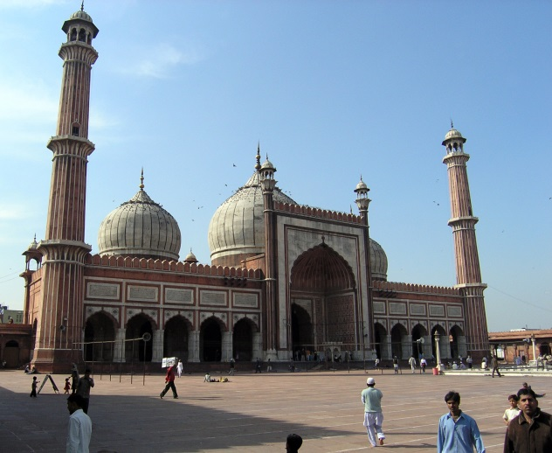

# Z E D E D U C A T I O N

A passport valid for at least 180 days and with at least two blank pages is required as well as a visa. Canadians must be in possession of a visa to visit India. You must obtain a visa prior to arrival or you will be refused entry into the country.

Holders of tourist visas can only stay in India for up to 180 consecutive days, even when the validity of the visa exceeds 180 days.

Travel Requirements

Things to do in Delhi

**Jama Masjid**

Jama Masjid (meaning Friday Mosque) is the largest mosque in Hindustan, and the 8th largest in the world, holding upto 25000 people. It was constructed by the emperor Shah Jahan, who had also constructed the Lal Qila and the Taj Mahal. Jama Masjid was built between 1644 and 1648 with red sandstone and marble by over 5000 artisans.

**Lal Qila**

Lal Qila (Red Fort) was the place of residence of several Mughal emperors for nearly 200 years until 1857. The red sandstone walls of the fort rise 33 meters high and were designed to keep out invaders. Contrustion began from1638 and were completed by1648. Within the walls of the fort lie Lahori gate, Delhi Gate, Mumtaz Mahal, Naubat Khana, Diwan-E-Aam, Diwan-E-Khas and many other structures.

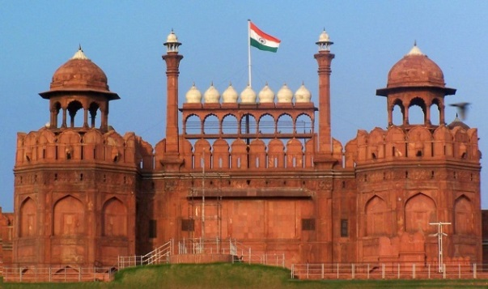

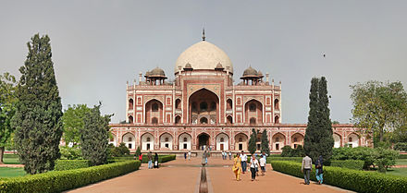

**Maqbarah-E-Humayun**

Maqbarah-E-Humayun, (Humayun’s Tomb), is the tomb of the emperor Nasir Ud-Din Mohammed Humayun who had once ruled from modern day Hindustan (Hindustan is the Indian name of India, particularly the northern areas) to Afghanistan. He ruled from 1530-1540 and again from 1555-1556. After the death of Humayun, his wife Haji had the tomb contructed in 1570. Inside the walled enclosure of Maqbarah-E-Humayun, there are garden squares, water channels and pathways as well as the monument which holds the emperors tomb. There are also the graves of other emperors of Hindustan.

|  |  |  |  |  |  |  |
| --- | --- | --- | --- | --- | --- | --- |
|  | **Day of Departure**  **June 23** | **Day of Arrival**  **June 24** | **Day 1**  **June 25** | **Day 2**  **June 26** | **Day 3**  **June 27** | **Day 4**  **June 28** |
| **Morning** |  | We will arrive at Brussels by 7:50AM. Our flight to Delhi will depart 10:10AM. | Arrive at Maqbara-E-Humayun by 11AM. We will tour the Maqbara unitl  1PM. | Conference | Arrive at Jama Masjid by 10AM. We will tour Jama Masjid until 11PM and have lunch. |  |
| **Afternoon** | Arrive at Toronto Pearson International Airport by 4:30PM. Our flight will depart at 6:30PM. |  |  | Conference | Arrive at Lal Qila by 1PM. We will tour the fort until 3PM. | Arrive at the Indira Gandhi International airport by 12:30AM. Our flight will leave 2:40AM.  Arrival at Brussels 7:55AM. Our flight to Toronto will depart 10:15AM |
| **Evening** |  | We will arrive at Delhi Indira Gandhi Airport at 9:45PM. Check in at Taj Mahal hotel. |  |  | Awards dinner and reception | Arrive in Toronto at 12:30PM. |

Works Cited

Flights

<https://secure.jetairways.com/Jetobe/OnlineBooking.aspx>

Accomodation

<http://www.tajhotels.com/luxury/city-hotels/the-taj-mahal-hotel-new-delhi/accommodations/luxury-suites.html>

Tourism

<http://www.delhitourism.gov.in/delhitourism/tourist_place/jama_masjid.jsp>

<http://www.delhitourism.gov.in/delhitourism/tourist_place/humayun_tomb.jsp>

<http://www.delhitourism.gov.in/delhitourism/tourist_place/red_fort.jsp>

Travel Requirements and Currency Exchange

<http://travel.gc.ca/destinations/india>

<http://www.xe.com/currencyconverter/>